Business Situation # 1: (20 Points) The Fire Department records how long it takes each of its trucks to reach the scene of a fire. The distribution of the arrival times is uniform with the minimum time being 2 minutes and the maximum time 15 minutes.
- Draw the uniform probability distribution diagram.
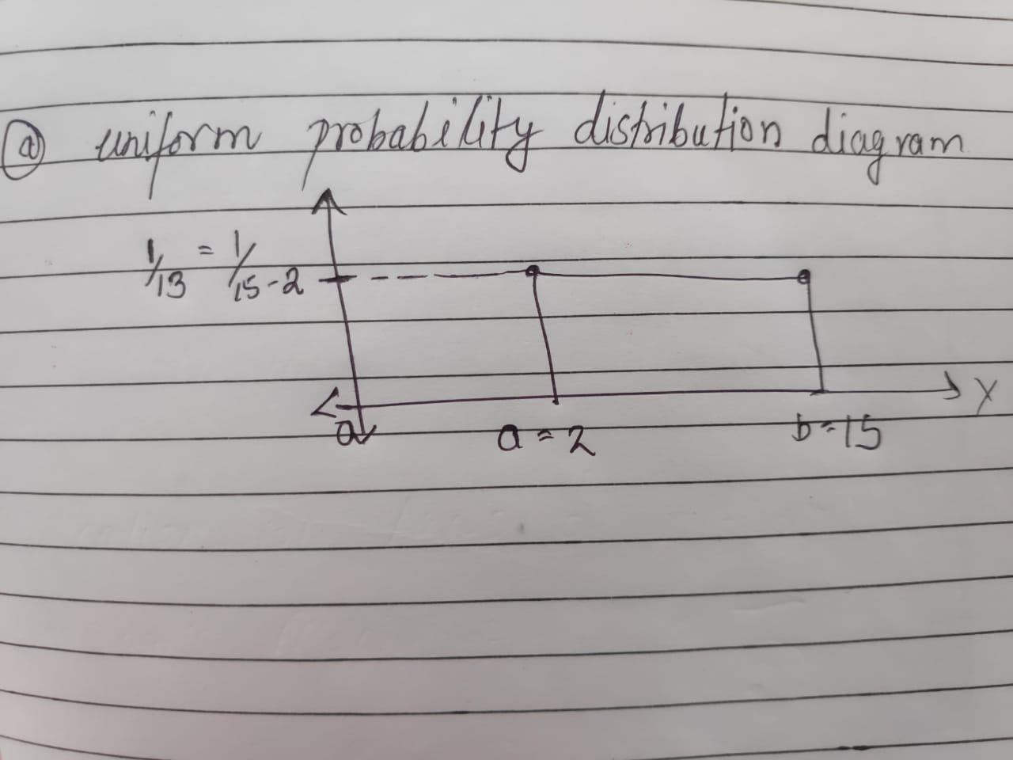
- What is the probability that a truck will reach a fire scene within 5 to 10 minutes?
Ans: P(5<=x<=10)=P(x<=10)-P(x<=5)=(10-2)/(15-2) –(5-2)/(15-2)=5/18=0.3846
- What is the expected time (mean time) until arrival?
Ans: expected time (mean time)=(a+b)/2=(2+15)/2=8.5minutes
- What is the standard deviation of truck arrival times?
Ans: standard deviation=sqrt(1/12(b-a)^2)=sqrt(1/12 x169)=3.7526 minutes
Business Situation # 2: (10 points) Seven sprinters have advanced to the final heat at a track meet.
- How many ways can they finish?
Ans: there are 7 sprinters they can be arranged in 7! Ways. Hence number of ways =7! = 5040
- How many ways can they finish in first, second and third place.
Ans: 3 sprinters from 7 can be arranged in 7P3 ways . hence the number of ways=7p3=210
Business Situation # 3: (10 points)In South Carolina’s Carolina 5 lottery, a player selects five different numbers from 1 to 36 (Inclusive). If the numbers selected match the players numbers in any order, the player wins.
- What is the total number of winning combinations?
Ans: Five number from 36 can be selected in 36C5ways .These 5 numbers can be arranged in 5! Ways hence number of winning combinations are 5!=120
- What is the probability of winning?
Ans: total possible combinations=36C5
Probability of winning =1/36C5=1/376992

Business Situation # 4: (15 points) The service manager for United Airlines is uncertain about the time needed for the ground crew to turn an airplane around from the time it lands until it is ready to takeoff. He has been told that the times seems to range between 15 to 45 minutes.
- Apply a uniform distribution to the turnaround.
F(x)=1/(b-a)=1/(45-15)=1/30=0.033
- Compute the mean
Mean=(a+b)/2=(45+15)/2=30 minutes
- Compute the standard deviation
Ans: standard deviation=sqrt(1/12(b-a)^2)=sqrt(1/12(45-15)^2)=8.66 minutes

Please select the appropriate option and explain why you did so.
1) If the variance is 81 grams, what is the standard deviation four times?
A) 0.600
B) 1.897
C) 6.000
D) 36.00
Ans: D ( standard deviation = square root of variance=9 and four times of standard deviation =
4 x 9=36 )

2) A total of 60% of the customers of a fast-food chain order a hamburger, French fries, and a drink. If a random sample of 15 cash register receipts is selected, what is the probability that 10 or more will show that the above three food items were ordered?
A) 0.186
B) 0.403
C) 0.000
D) 1.000
Ans: B( given p= 0.6 n=15 so p(10<=x<=15)=1- binomcdf(15, 0.6,9)=0.403

3) Judging from recent experience, 15% of the computer keyboards produced by an automatic, high-speed machine are defective. If six keyboards are randomly selected, what is the probability that none of the keyboards are defective?
A) 0.001
B) 0.167
C) 0.735
D) 0.500
Ans: C( 15% of the computer keyboards are defective then 95% are not defect so 0.95^6=0.735)

4) On a very hot summer day, 5% of the production employees at Midland States Steel are absent from work. The production employees are randomly selected for a special in-depth study on absenteeism. What is the probability of randomly selecting 10 production employees on a hot summer day and finding that none of them are absent?
A) 0.002
B) 0.344
C) 0.599
D) 0.100
Ans:C(This is a binomial probability. The probability of getting r success out of n trials where the probability of success each trail is p and probability of failure each trail is q is given by:n!(p^r)[q^(n-r)]/r!(n-r)!. Here n=10,r=0,p=0.05 therefore answer is 0.599)

5) A listing of all possible outcomes of an experiment and their corresponding probabilities of occurrence is called a ________.
A) random variable
B) probability distribution
C) subjective probability
D) frequency distribution
Ans: B(A listing of all possible outcomes of an experiment and their corresponding probabilities of occurrence is called a probability distribution
)
6) Which one of the following is a condition of the binomial distribution?
A) Non-Independent trials
B) Only two outcomes
C) The probability of success changes from trial to trial
D) Sampling at least 10 trials
Ans:B(Each observation represents one of two outcomes(“success” or “failure”))

7) Which is true for a binomial distribution?
A) There are 10 or more possible outcomes.
B) The probability of success remains the same from trial to trial.
C) The value of π is equal to 1.50.
D) It approximates the Poisson distribution.
Ans: B (in binomial distribution Each observation represents one of two outcomes (“success” or “failure”) so the probability of success remains the same from trial to trial.)

8) Sponsors of a local charity decided to attract wealthy patrons to its $500-a-plate dinner by allowing each patron to buy a set of 20 tickets for the gaming tables. The chance of winning a prize for each of the 20 plays is 50–50. If you bought 20 tickets, what is the chance of winning 15 or more prizes?
A) 0.250
B) 0.021
C) 0.006
D) 0.750
Ans: B(This is a binomial probability. The probability of getting r success out of n trials where the probability of success each trail is p and probability of failure each trail is q is given by:n!(p^r)[q^(n-r)]/r!(n-r)!. so n=20 p=0.5 q=0.5 r= 15,16,17,18,19,20
P(15)=0.0148
P(16)=0.0046
P(17)=0.0011
P(18)=0.0002
P(19)=0.00002
P(20)=0.000001
The sum is 0.021

9) What kind of distributions are the binomial and Poisson probability distributions?
A) Discrete
B) Continuous
C) Both discrete and continuous
D) Neither discrete or continuous
Ans: A (Both binomial and poisson probability are Discrete probability distributions)

10) Which of the following is not correct about a probability distribution?
A) The sum of all possible outcomes must not equal 1.0.
B) The outcomes must be mutually exclusive.
C) The probability of each outcome must be between 0.0 and 1.0 inclusive.
D) All of these answers are correct.
Ans: A(The sum of all possible outcomes must equal 1.0.)

11) Data show that the weight of an offensive linesman may be any weight between 200 and 350 pounds. The distribution of weight is based on a ________.
A) Continuous random variable
B) Discrete random variable
C) Qualitative variable
D) All of these answers are correct.
Ans:A( random variable weight can be measure to an infinite degree of precision there fore the random variable can be any 200 and 350 pounds)

12) Carlson Jewelers permits the return of their diamond wedding rings, provided the return occurs within two weeks of the purchase date. Their records reveal that 10% of the diamond wedding rings are returned. Five different customers buy a wedding ring. What is the probability that none of the customers return a ring?
A) 0.250
B) 0.073
C) 0.590
D) 0.500
Ans:C(This is a binomial probability. The probability of getting r success out of n trials where the probability of success each trail is p and probability of failure each trail is q is given by:n!(p^r)[q^(n-r)]/r!(n-r)!. so n=5, r=0 p=0.10 q= 0.90 so answer is 0.590)

13) In a large metropolitan area, past records revealed that 30% of all the high school graduates go to college. From 20 graduates selected at random, what is the probability that exactly 8 will go to college?
A) 0.114
B) 0.887
C) 0.400
D) 0.231
Ans:A (using binomial distribution we have : n=20 p=0.30 q=1-0.30 r=8 so p=0.114)
14) Chances are 50–50 that a newborn baby will be a girl. For families with five children, what is the probability that all the children are girls?
A) 0.900
B) 0.031
C) 0.001
D) 0.250
Ans:B( probality =1/2*1/2*1/2*1/2*1/2=1/32=0.031)

15) A manufacturer of headache medicine claims it is 70% effective within a few minutes. That is, out of every 100 users, 70 get relief within a few minutes. A group of 12 patients are given the medicine. If the claim is true, what is the probability that eight have relief within a few minutes?
A) 0.001
B) 0.168
C) 0.667
D) 0.231
Ans:D( n=12 p=0.7 p(x=8)12C8(0.7)^8*(0.3)^4=0.231)
16) A true/false test consists of six questions. If you guess the answer to each question, what is the probability of getting all six questions correct?
A) 0
B) 0.016
C) 0.062
D) 0.250
Ans:B(probality =1/2*1/2*1/2*1/2*1/2*1/2=1/64=0.016)

17) A tennis match requires that a player win three of five sets to win the match. If a player wins the first two sets, what is the probability that the player wins the match, assuming that each player is equally likely to win each set?
A) 0.500
B) 0.125
C) 0.875
D) 0.000
Ans:C

18) Which of the following is a characteristic of a binomial probability distribution?
A) Each outcome is not mutually exclusive.
B) Each trial is not independent.
C) The probability of success remains changes from trial to trial.
D) The number of trials is unlimited.
Ans: these all options are not characteristics of a binomial probability distribution because outcome is mutually exclusive with fixed number of independent trail and the probability of success remains same from trail to trail)
19) What must you know to develop a binomial probability distribution?
A) The probability of success
B) The probability of success and the number of trials
C) The probability of success and the number of successes
D) The number of trials and the number of successes
Ans: B ( for binomial probability distribution we have to now the probability of success and number of trails)

20) David's gasoline station offers 4 cents off per gallon if the customer pays in cash and does not use a credit card. Past evidence indicates that 40% of all customers pay in cash. During a one-hour period, 15 customers buy gasoline at this station. What is the probability that at least 10 pay in cash?
A) 0.024
B) 0.033
C) 0.009
D) 0.976
Ans:B(Applying the binomial distribution, go to the binomial probability table, find the case where the number of trials is n = 15 and the probability of success is n = 40. Find the rows where x, the number of successes, is 10, 11, 12, 13, 14, and 15. Find the corresponding probabilities and sum them: 0.024 + 0.007 + 0.002 + 0.00 + 0.00 + 0.00 = 0.033)

21) David's gasoline station offers 4 cents off per gallon if the customer pays in cash and does not use a credit card. Past evidence indicates that 40% of all customers pay in cash. During a one-hour period, 15 customers buy gasoline at this station. What is the probability that all 15 pay in cash?
A) 0.0
B) 0.1
C) 0.9
D) 1.0
Ans:A(Applying the binomial distribution, go to the binomial probability table, find the case where the number of trials is n = 15 and the probability of success is n = 40. Find the row where x, the number of successes, is 15. Find the corresponding probability of 0.000)

22) David's gasoline station offers 4 cents off per gallon if the customer pays in cash and does not use a credit card. Past evidence indicates that 40% of all customers pay in cash. During a one-hour period, 15 customers buy gasoline at this station. This situation is an example of what type of discrete probability distribution.
A) Continuous probability distribution
B) Poisson probability distribution
C) Binomial probability distribution
D) Hypergeometric probability distribution
Ans: C( this is situation of Binomial probability distribution)

23) A company is studying the number of monthly absences among its 125 employees. The following probability distribution shows the likelihood that people were absent 0, 1, 2, 3, 4, or 5 days last month.

Number of Days Absent | Probability
0 | 0.60
1 | 0.20
2 | 0.12
3 | 0.04
4 | 0.04
5 | 0.00

What is the variance of the number of days absent?
A) 1.1616
B) 1.41
C) 5.00
D) 55.52
Ans:A ( variance = Σx^2p(x)-mean^2
By putting value we get 1.1616)

24) For the following distribution:

x | P(x)
0 | 0.130
1 | 0.346
2 | 0.346
3 | 0.154
4 | 0.026

What is the mean of the distribution?
A) 1
B) 2.5
C) 1.604
D) 3
Ans: C(0 x 0.130=0
1 x 0.346=0.346
2 x 0.346=0.692
3 x 0.154=0.462
4 x 0.026=0.104)
So mean= sum of all=1.604

25) For the following distribution:

x | P(x)
0 | 0.130
1 | 0.346
2 | 0.346
3 | 0.154
4 | 0.026

What is the variance of the distribution?
A) 1.1616
B) 0.964
C) 0.982
D) 1.000
Ans B( variance = Σx^2p(x)-mean^2
By putting value we get 0.964)

26) For the following distribution:

x | P(x)
0 | 0.027
1 | 0.189
2 | 0.441
3 | 0.343

What is the mean of the distribution?
A) 2.1
B) 1.5
C) 0.441
D) 2
Ans: A( 0 x 0.027=0
1 x 0.189=0.189
2 x 0.441=0.882
3 x 0.343=1.029
Mean=2.1)

27) For the following distribution:

x | P(x)
0 | 0.027
1 | 0.189
2 | 0.441
3 | 0.343

What is the variance of the distribution?
A) 2.1
B) 0.63
C) 3.9
D) 2.754
Ans:B ( variance = Σx^2p(x)-mean^2
By putting value we get 0.63)

28) For a binomial distribution, the mean is 0.6 and n = 6. What is π for this distribution?
A) 0.5
B) 1.00
C) 0.3
D) 0.1
Ans:D(mean= n x π so answer is 0.1)

29) For a binomial distribution, the mean is 24.0 and n = 8. What is π for this distribution?
A) 0.5
B) 1.00
C) 3.0
D) 0.1
Ans: C(mean= n x π so answer is 3)

30) In which of the following discrete distributions does the probability of a success vary from one trial to the next?
A) Binomial
B) Poisson
C) Hypergeometric
D) All of these answers are correct.
Ans:C (Hypergeometric distribution is a discrete probability distribution that describes the success from vary from one trail to the next)

